**Machine Learning**

**Lab Assignment 1**



Sherly Lutfi Azkiah Sulistyawati 2341720241

**D-IV INFORMATICS ENGINEERING STUDY PROGRAM**

**INFORMATION TECHNOLOGY DEPARTMENT**

**POLITEKNIK NEGERI MALANG**

**Part 1**

1. Create a notebook file named TG1_NIM_NAME.ipynb. Example: TG_0028119106_M AFIF HENDRAWAN.ipynb.
2. Install the following libraries in the notebook,
   1. PyPREP
   2. Scipy
   3. wandb
   4. pyECG

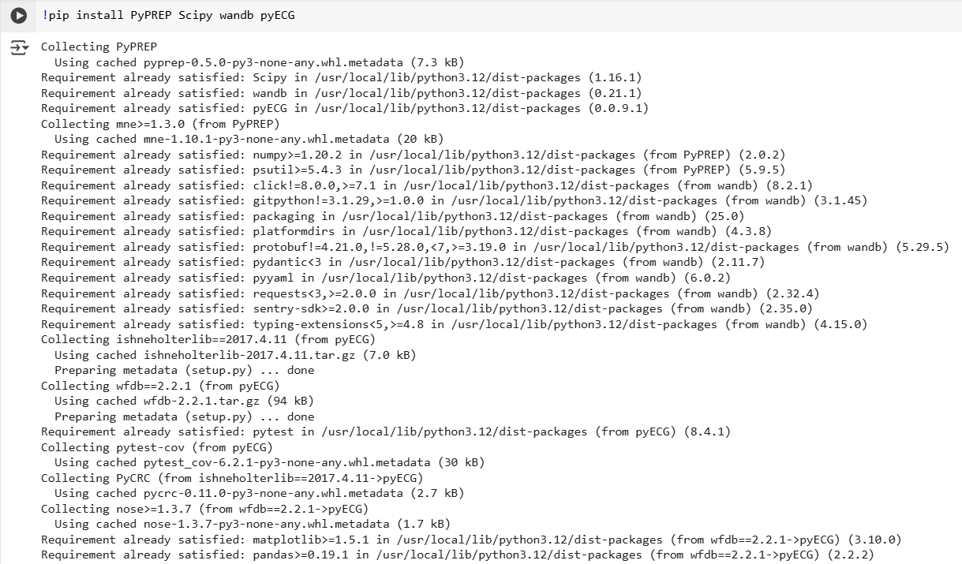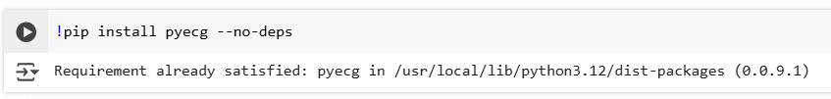

1. Explain the use of each library.

**PyPREP**

* A Python implementation of the *PREP pipeline*, used for preprocessing EEG (electroencephalography) data.
* It helps clean EEG signals by removing noise, referencing, and preparing the data for machine learning tasks in neuroscience or medical research.

**Scipy**

* A fundamental library for scientific computing in Python.
* Provides functions for optimization, statistics, signal processing, linear algebra, and more.
* Often used in machine learning projects for mathematical operations beyond NumPy.

**wandb (Weights & Biases)**

* A tool for experiment tracking and model monitoring in machine learning.
* Helps log hyperparameters, visualize training progress, compare model performance, and collaborate with teams.
* Widely used in ML research and production to maintain reproducibility.

**pyECG**

* A Python package for processing and analyzing ECG (electrocardiogram) signals.
* Provides tools to detect heartbeats, extract features, and analyze cardiac health.
* Useful in medical AI projects related to heart disease detection.

**Part 2**

1. Provide examples of actions that violate ethical and legal norms regarding the use of artificial intelligence. Include references used.

**Data Privacy Violation**

Using personal data (e.g., medical or financial) without consent.

Example: Cambridge Analytica scandal (misuse of Facebook data).

Reference: Cadwalladr, C., & Graham-Harrison, E. (2018). The Cambridge Analytica Files. The Guardian.

**Bias & Discrimination**

AI recruiting systems rejecting candidates based on gender or race due to biased training data.

Reference: Dastin, J. (2018). Amazon scraps secret AI recruiting tool that showed bias against women. Reuters.

**Deepfake Misuse**

Creating fake videos/images for political manipulation or harassment.

Reference: Chesney, R., & Citron, D. (2019). Deep Fakes: A Looming Challenge for Privacy, Democracy, and National Security.

1. Provide examples of the impact of energy and environment on the use of artificial intelligence and how to address them (you may give personal opinions). Include references used.

AI has notable energy and environmental impacts. For example, training large models like GPT-3 consumes massive electricity—around 1,287 MWh, producing 552 tons of CO₂ emissions (Patterson et al., 2021). The growing demand for GPUs and TPUs also contributes to electronic waste. To address these challenges, solutions include using green data centers, optimizing models through techniques like pruning and quantization, developing more efficient algorithms, and promoting hardware recycling. These steps can help balance AI’s benefits with sustainability (Strubell, Ganesh, & McCallum, 2019).